National University of Computer and Emerging Sciences, Lahore Campus

 | Course Name: | Information Security | Course Code: | CS3002
 | Program: | BCS | Semester: | Fall 2026
 | Sections: |  | Total Marks: | 10
 | Due Date: | 13-10-2026 | Weight | ~1.5%
 | Exam Type: | Assignment 3 | Page(s): | 2

PKI & Certificate Signing
This assignment provides hands-on experience in Public Key Infrastructure (PKI) management. It creates the following environment where a webserver and client want to communicate over HTTPS (secure session), but client need a trusted 3rd party that acts as Certificate Authority (CA) and issues public key certificates.
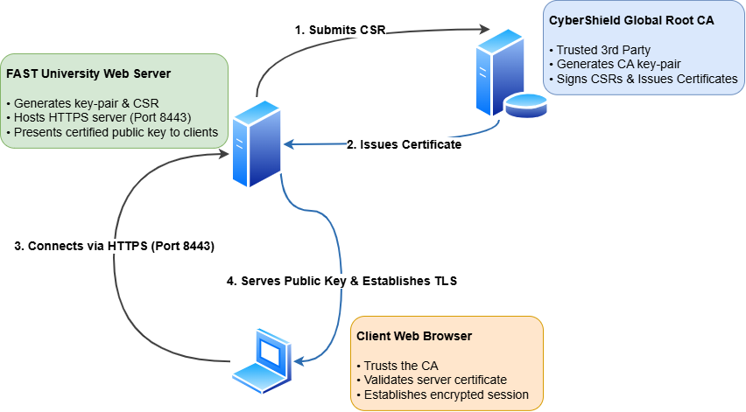

1. Environment Setup
- Obtain EasyRSA from the official GitHub Releases page.
It requires no installation. Simply download and extract the ZIP archive (or tgz archive for Mac/Linux).
- Create a folder named pki_lab to keep all the files in this assignment.
- Inside pki_lab, create two distinct subfolders:
  - CA (Dedicated environment for the Certificate Authority)
  - Server (Dedicated environment for the Web Server requestor)
- Extract a fresh, independent copy of the EasyRSA files into both the CA and Server directories.

2. Setting Up the Certificate Authority (CA)
In this task, you will initialize a clean PKI structure for the Certificate Authority and establish the Root CA certificate.

2.1
Open a terminal in the CA subfolder (on Windows, launch EasyRSA-Start.bat) and execute:
./easyrsa init-pki
This command initializes a completely fresh Public Key Infrastructure environment in the target folder. It builds a pki/ directory hierarchy containing clean configuration files, empty certificate tracking databases (index.txt), serial number tracking counters, and subdirectories for private keys and certificates.

2.2
In the same CA terminal, execute the following command to generate the Root CA:
./easyrsa build-ca
During execution:
- You will be prompted to enter a passphrase to protect the CA's private key (ca.key).
- When prompted for the Common Name (CN) / Distinguished Name (DN), enter an authoritative name: CyberShield Global Root Authority.
This step creates the secret private key in pki/private/ca.key and the self-signed Root CA public certificate in pki/ca.crt.

3. Generating Server Certificate Signing Request
In this task, you will set up the Server environment and generate a key pair along with a Certificate Signing Request (CSR).

3.1
Open a terminal in the Server subfolder and initialize its PKI environment:
./easyrsa init-pki

3.2
Generate a certificate request. This step includes generating a public-private key pair. We specify a short name nuces to refer to those keys and request. nopass option skips setting a passphrase for private key.
./easyrsa gen-req nuces nopass
When prompted for the Common Name, specify: FAST University

4. Transferring CSR and Signing Certificate
The CSR must be transferred to Certificate Authority in some way. For this lab, you will just manually copy the request file across directories.

4.1
Locate the generated CSR file at Server/pki/reqs/nuces.req and copy it manually into the CA requests subfolder: CA/pki/reqs/.

4.2
Return to your CA terminal and issue the signed certificate:
./easyrsa sign-req server nuces
Confirm the request details and enter your CA key passphrase when prompted. This generates the signed X.509 certificate file: CA/pki/issued/nuces.crt.

5. Web Server Deployment and Browser Trust Verification

5.1
- Create a new directory named webserver directly under your main pki_lab directory.
- Copy the Server private key nuces.key from Server/pki/private/ into webserver/. Similarly, copy the newly issued certificate nuces.crt from CA/pki/issued/ into webserver/.
- Place the supplied Python HTTPS server script (https_server.py) into the webserver/ directory. Note that this script requires certificate and key files with the same names mentioned above.

5.2
Open a terminal in the webserver directory and launch the HTTPS server:
python https_server.py

5.3
- Open Mozilla Firefox and visit: https://localhost:8443.
- Firefox will present a security warning screen. Click Advanced to see details of the security problem.
- Click View the site’s Certificate. Verify that the Subject CN displays FAST University and the Issuer displays CyberShield Global Root Authority.
- Click Proceed to localhost:8443 to establish the secure connection and view the loaded web page.

Deliverables
A single document containing:
- Screenshots of directory structure of CA/, Server/, and webserver/
- Screenshots of Firefox certificate viewer window, and webpage loaded successfully
- Brief answers
  - What are the contents of CSR sent by server to CA?
  - In real production environments, how do servers send their CSRs to CA (the part you did with manual file copy)?
  - What key CA uses to sign the certificates. Identify the file.
  - Why client browser shows a security error?

